HBAP test Account creation GSR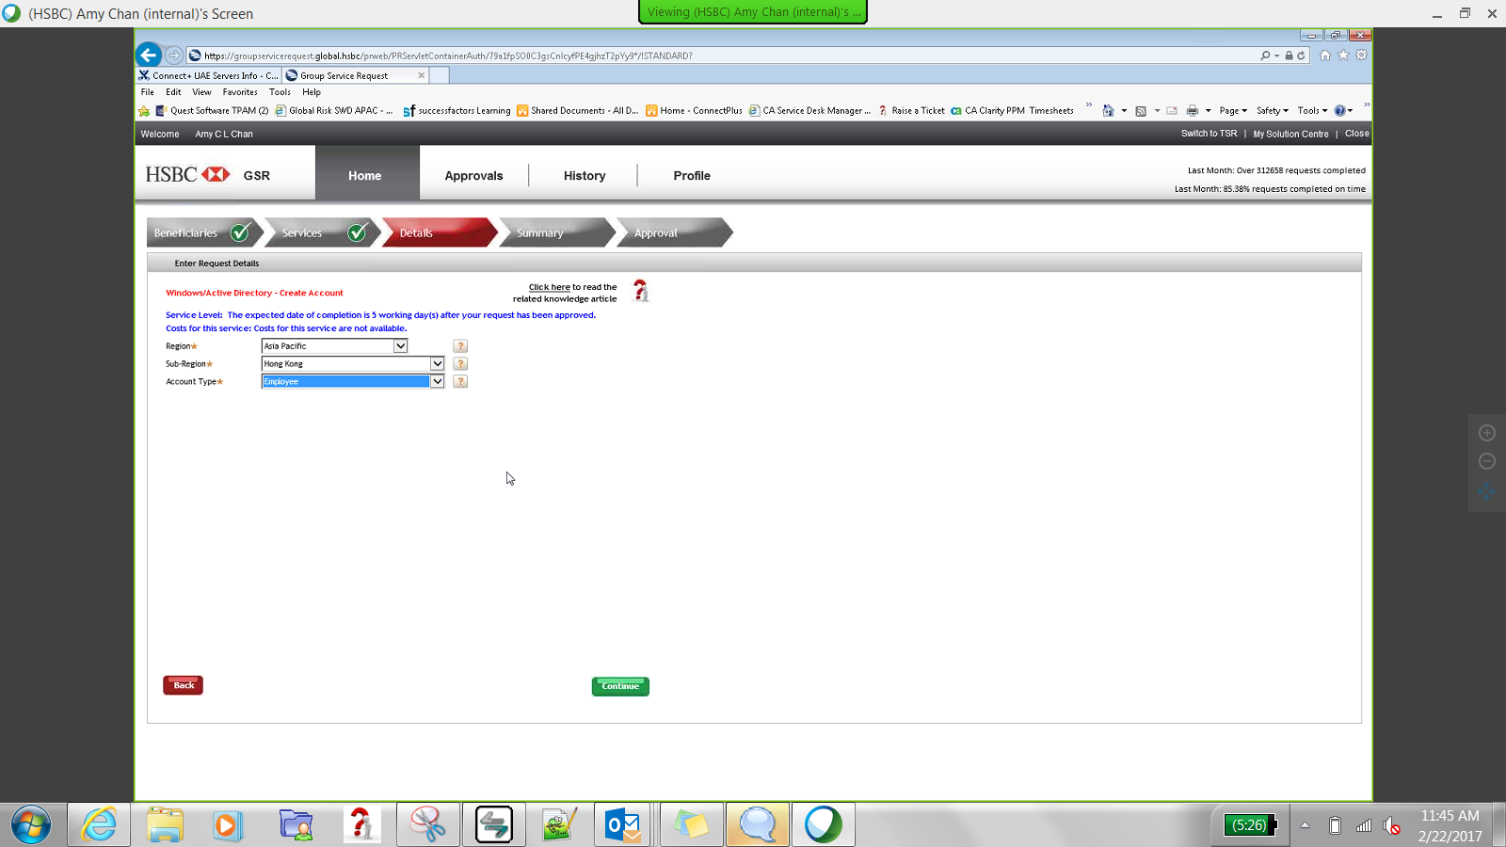



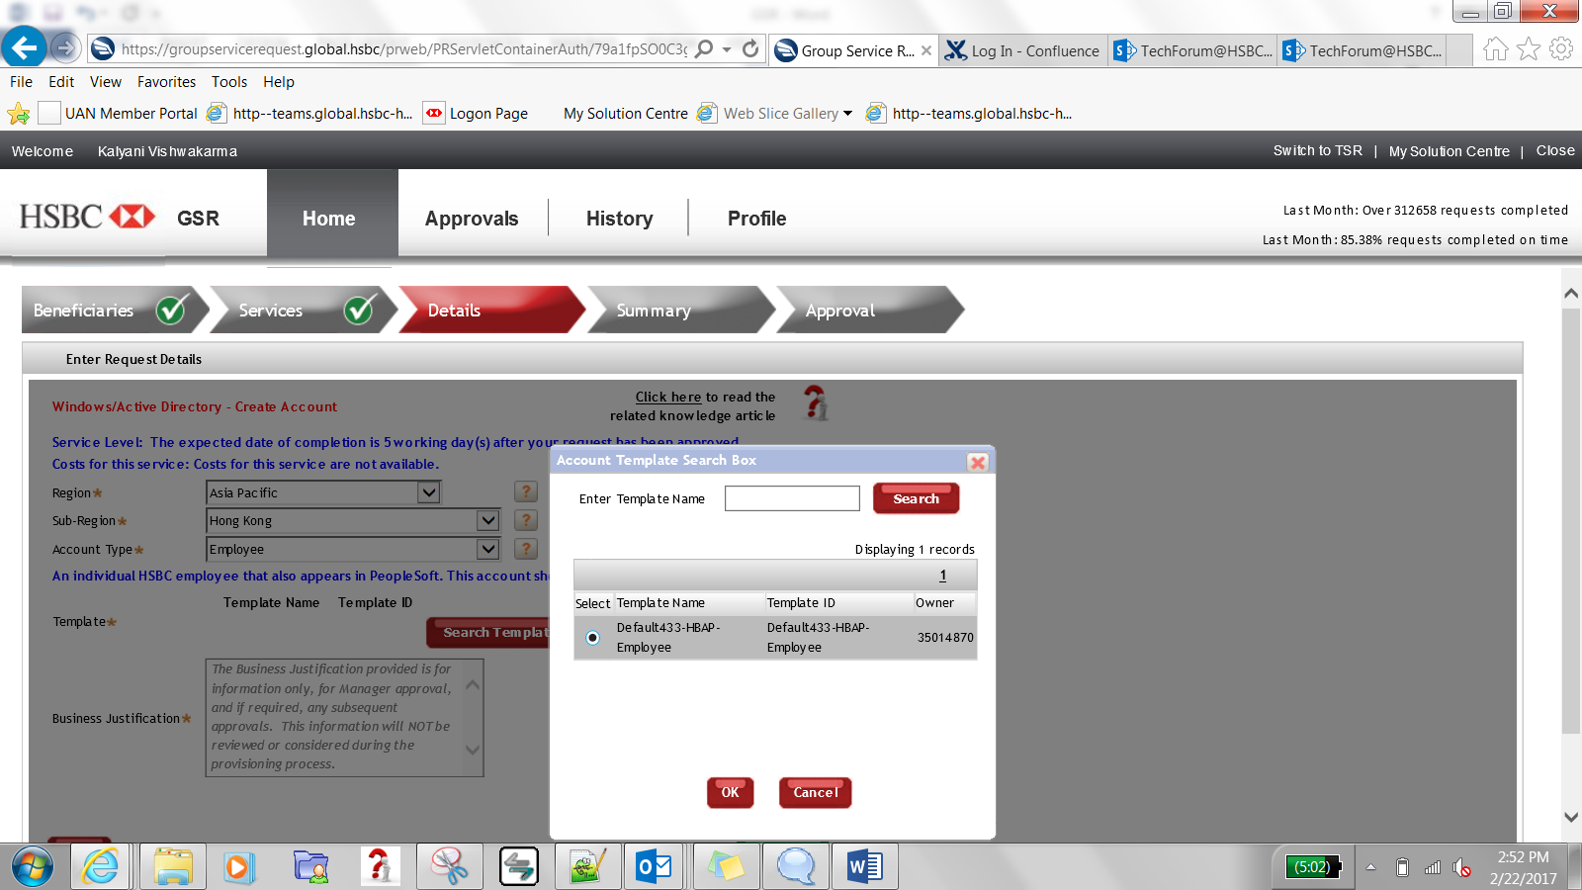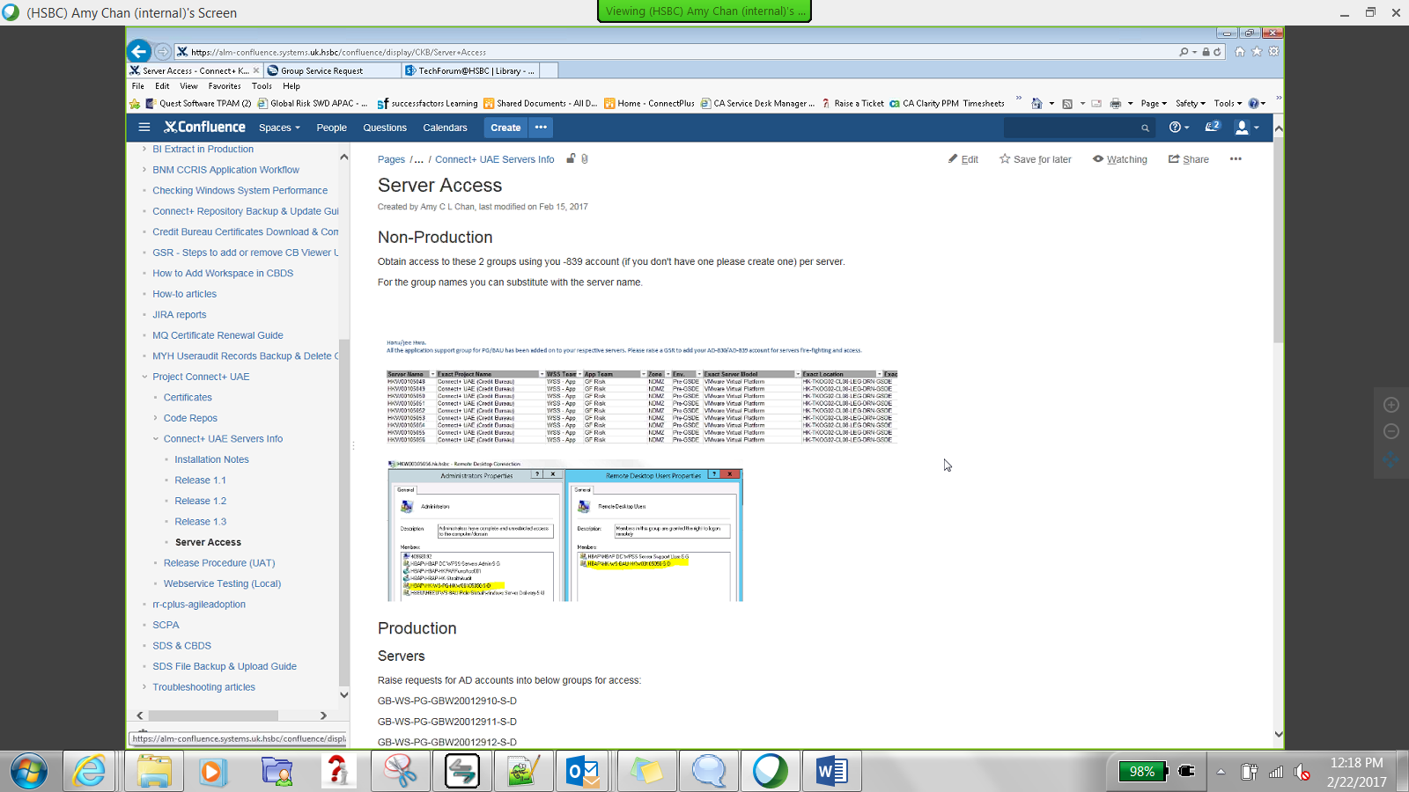

**GSR for Malaysia MYH serevr access-**

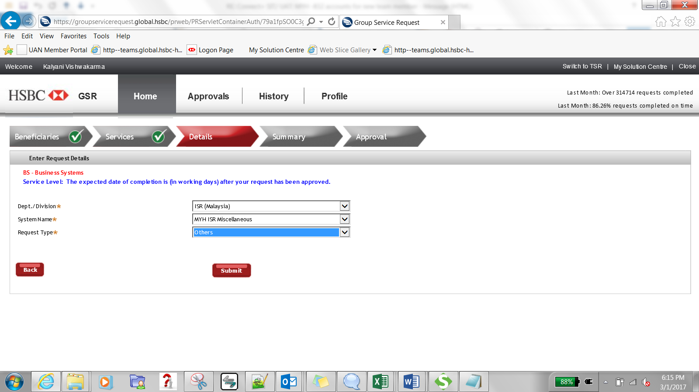

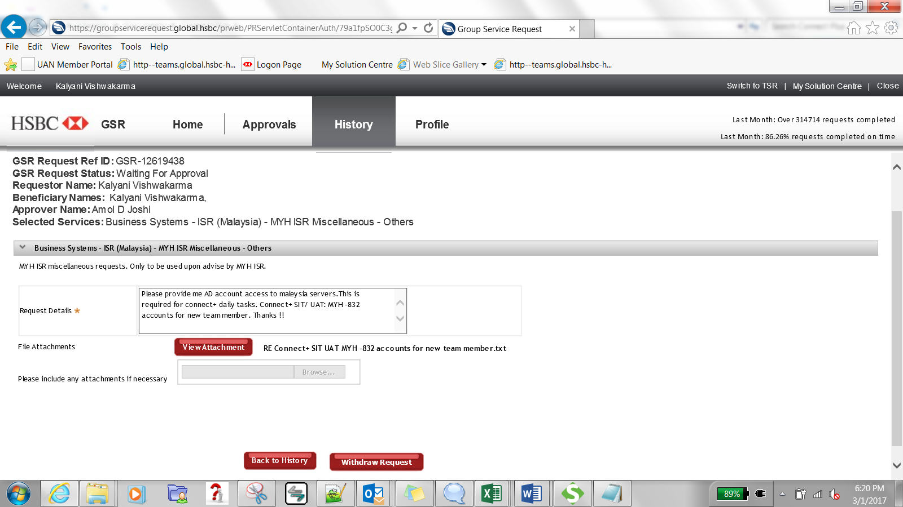

GSR guide for adding your windows AD Id to get UAE server access🡪

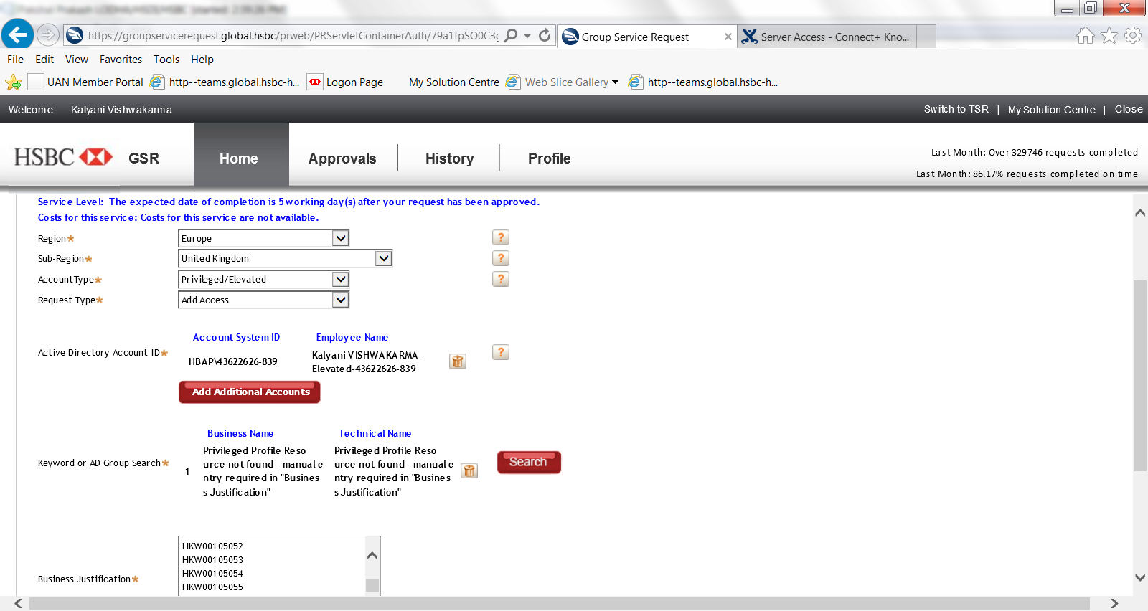**GSR-12637431**

**GSR for PROD UAE server access🡪>**

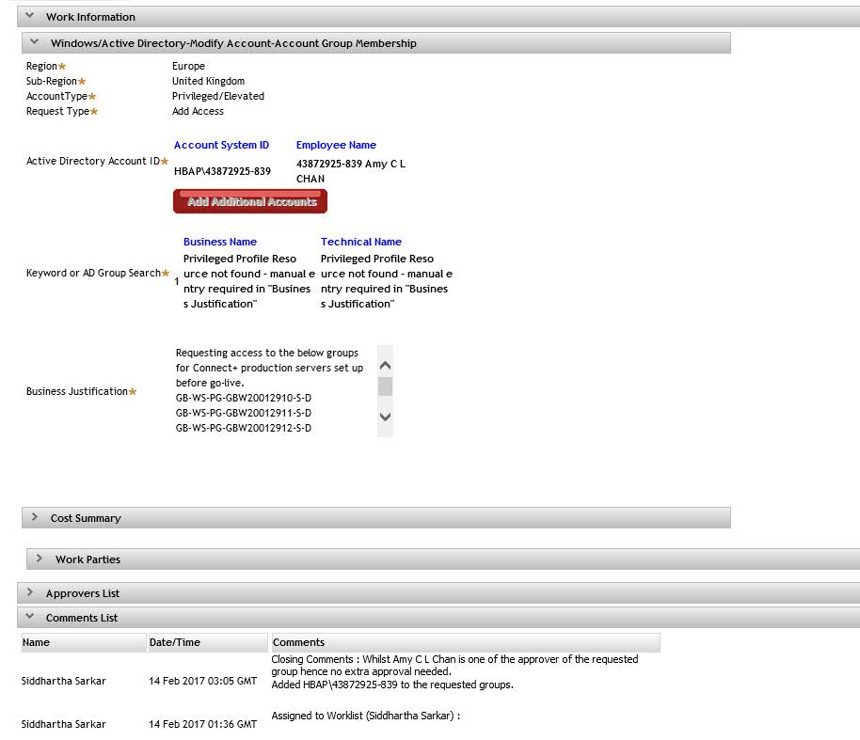

SIT-UAT UAE server access GSR mine🡪

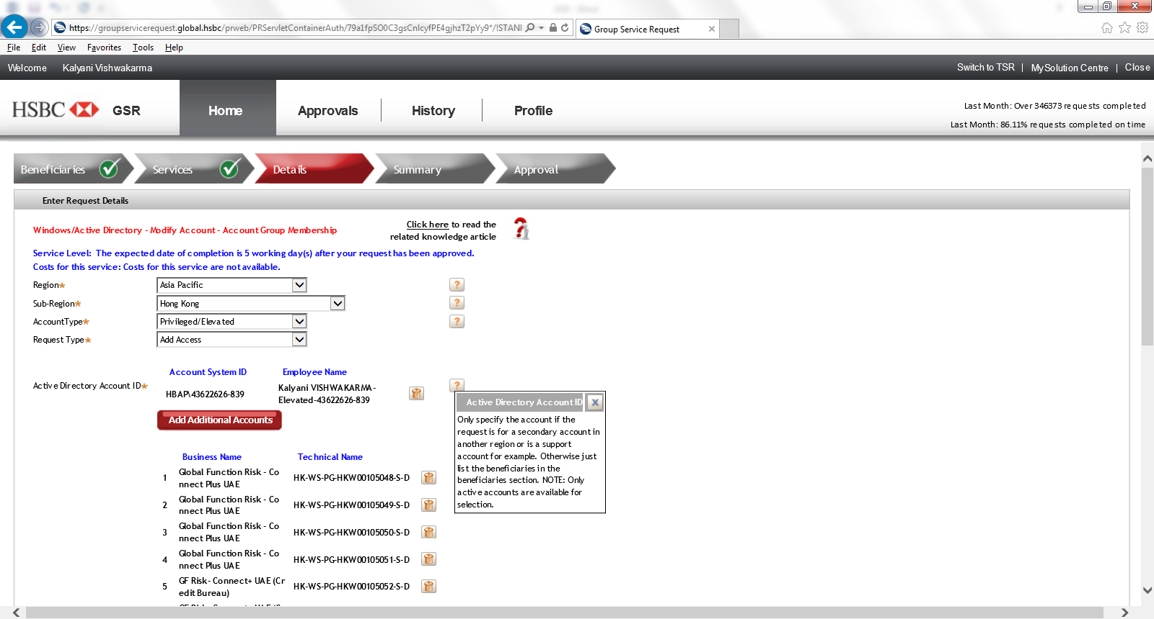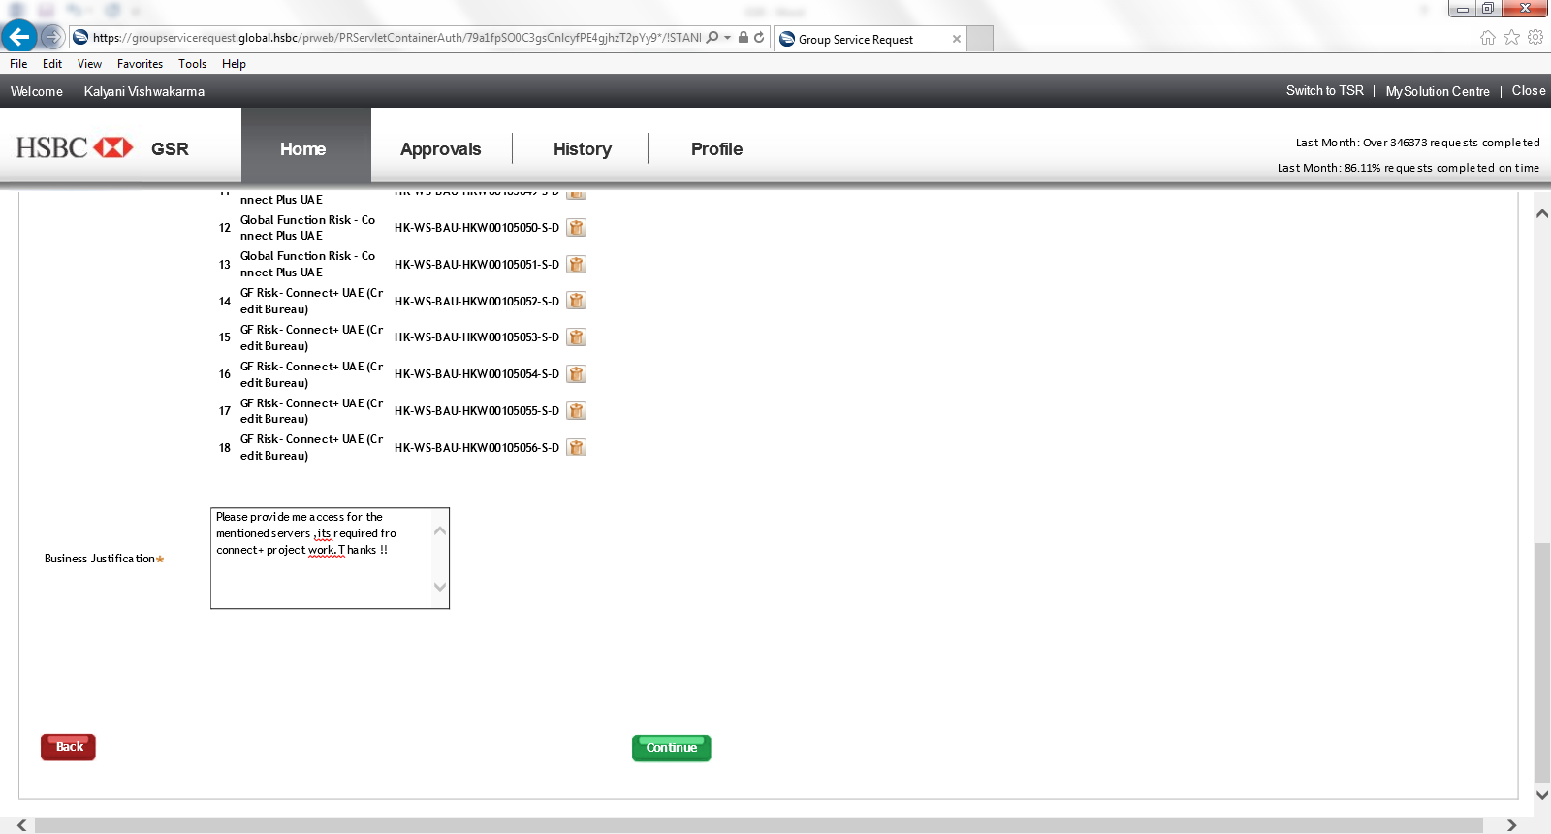

In the AD group search, you need to search and add ALL of the below list of groups:

HK-WS-PG-HKW00105048-S-D

HK-WS-PG-HKW00105049-S-D

HK-WS-PG-HKW00105050-S-D

HK-WS-PG-HKW00105051-S-D

HK-WS-PG-HKW00105052-S-D

HK-WS-PG-HKW00105053-S-D

HK-WS-PG-HKW00105054-S-D

HK-WS-PG-HKW00105055-S-D

HK-WS-PG-HKW00105056-S-D

HK-WS-BAU-HKW00105048-S-D

HK-WS-BAU-HKW00105049-S-D

HK-WS-BAU-HKW00105050-S-D

HK-WS-BAU-HKW00105051-S-D

HK-WS-BAU-HKW00105052-S-D

HK-WS-BAU-HKW00105053-S-D

HK-WS-BAU-HKW00105054-S-D

HK-WS-BAU-HKW00105055-S-D

HK-WS-BAU-HKW00105056-S-D

GSR for Sonar and UFT🡪

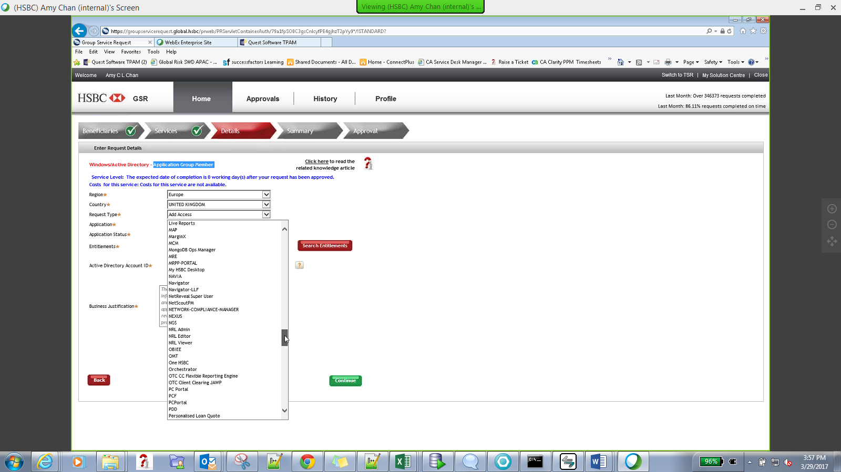

Githbus GSR

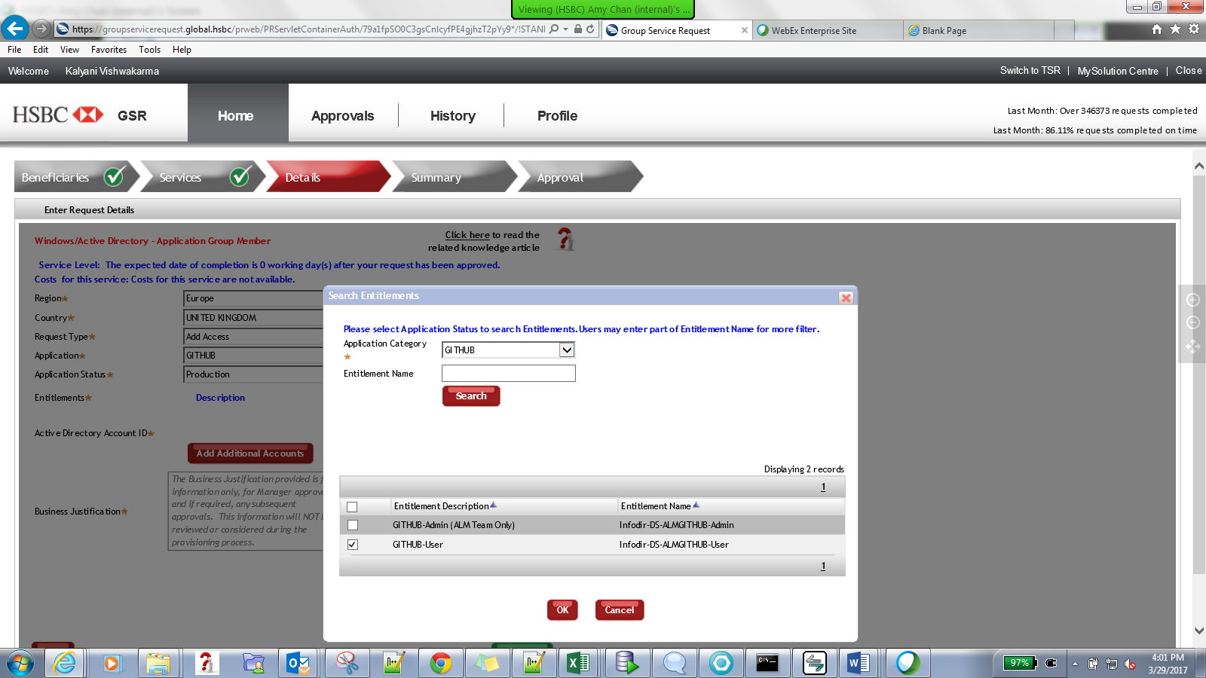

Sonar access🡪

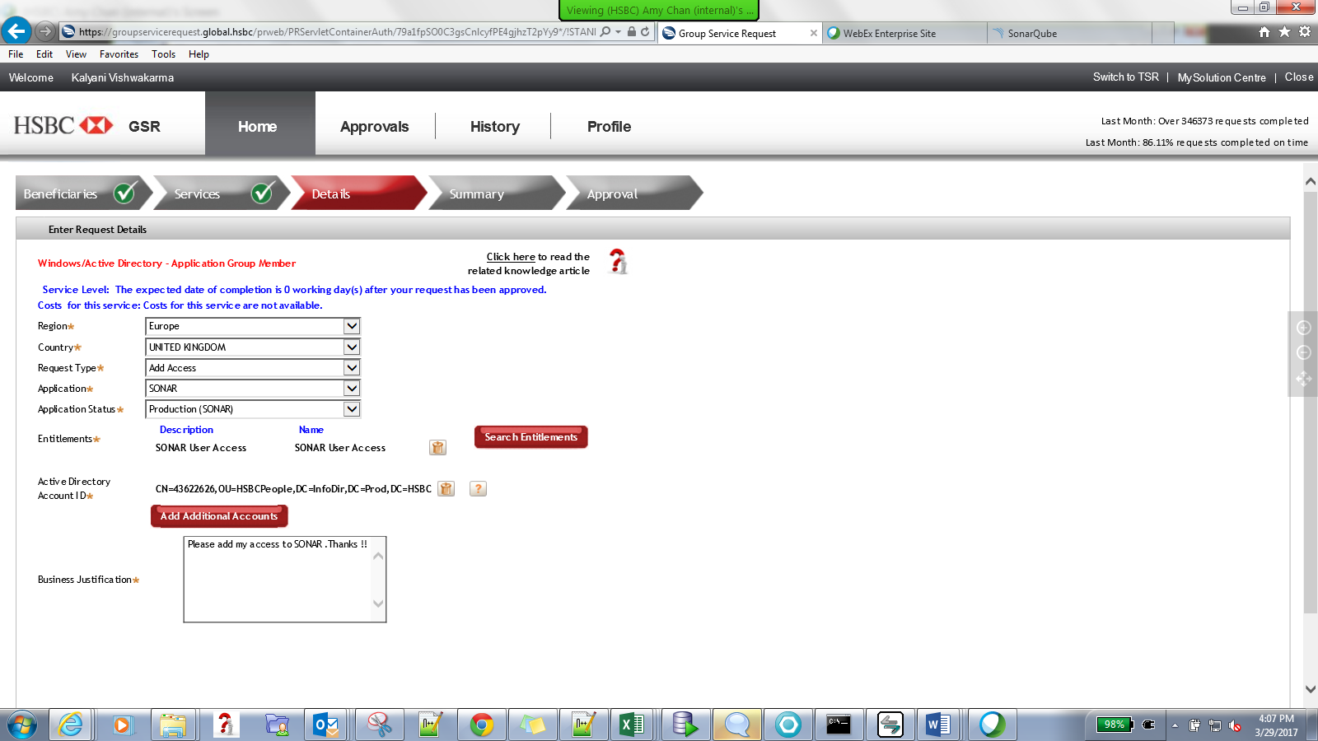

GSR for UFT🡪

**GSR-12939924**

